

chomba tiku mwape

ST10284034 POE



Instruction manual on how to use the Contract Monthly Claim System

First start by Registering for an account by Inserting Entering your full Name, Email Address,

Create a username and password

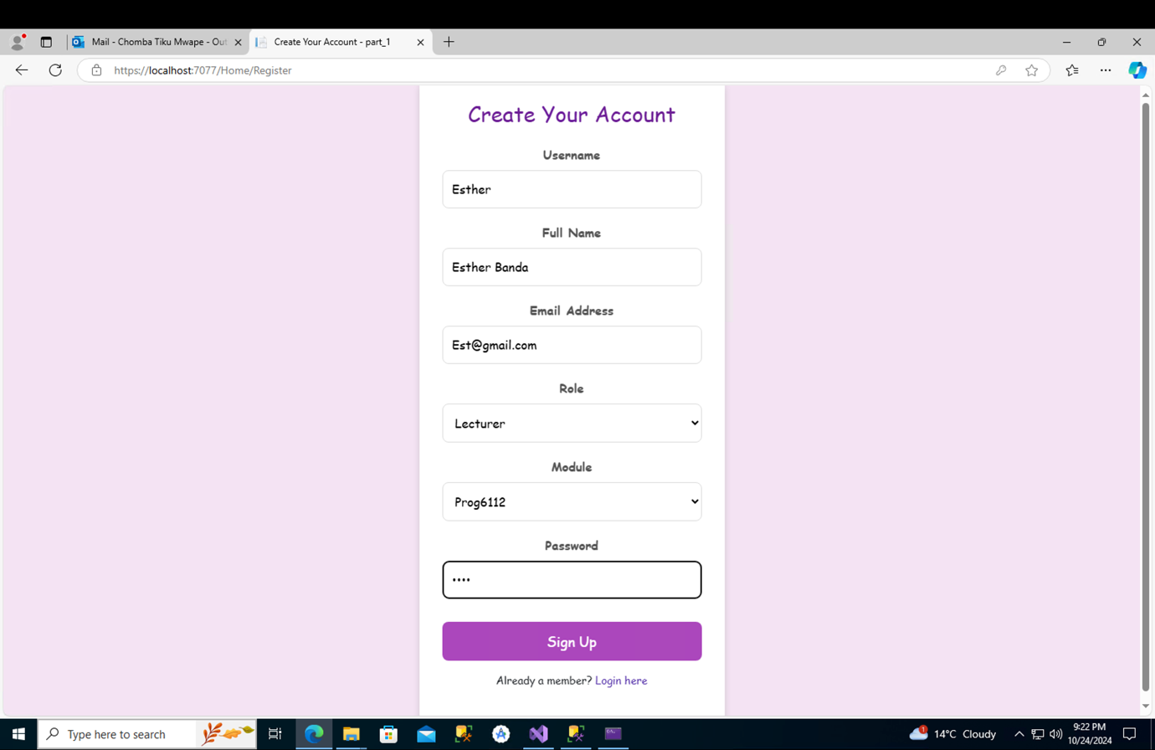

Then login using username and password

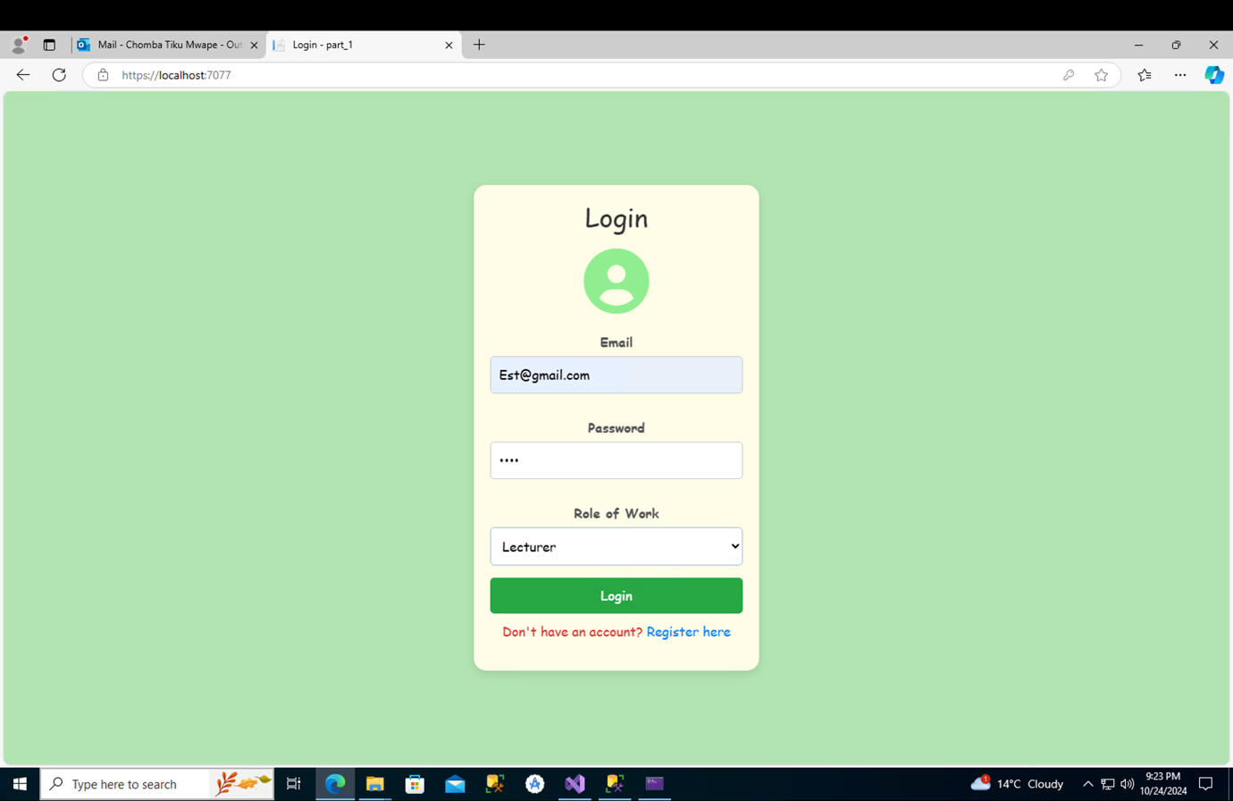

Step3 would be for lecturers to submit a claim they would Click submit claim now

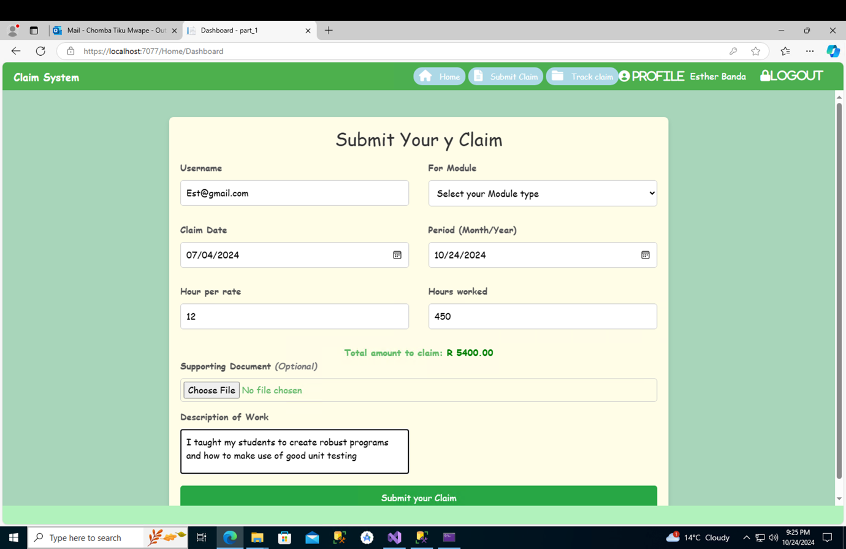

STEP 4 The program coordinator will be able to login or create an account if he or she has not registered his account like everyone else in order to give approval or rejection the claim

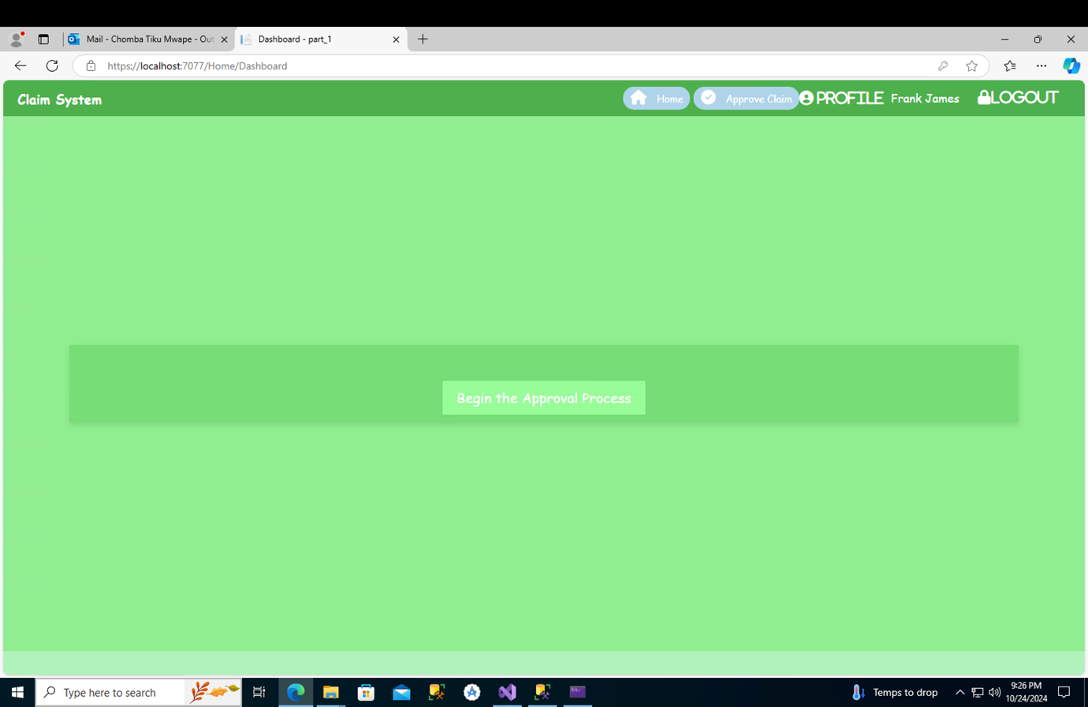

STEP 5 He/she will be lead to a claims page where they will be able to see the claims submitted 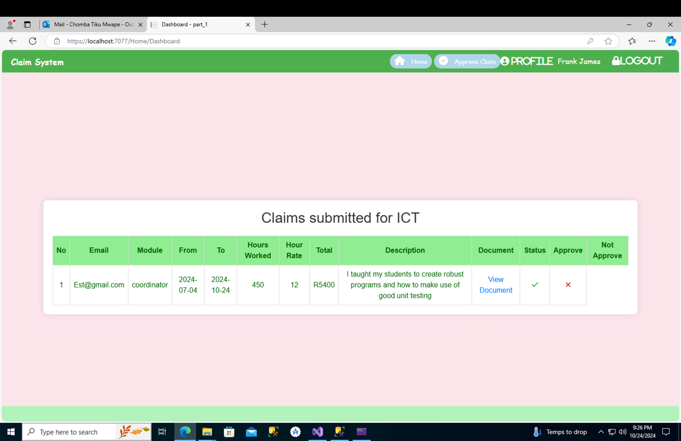

Step 6 He/she will get a “success” message for approval or success for rejection 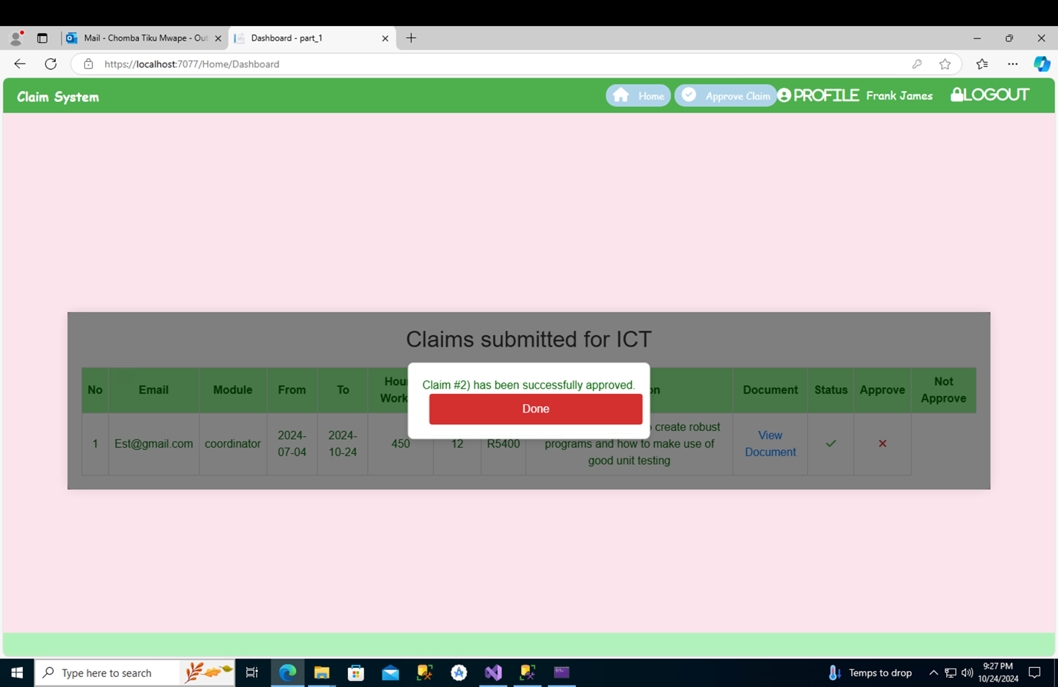

LASTLY the lecturer will be able to go back into his profile under “track claims” to see whether or not the claim has been approved

